PERSONAL INFORMATION

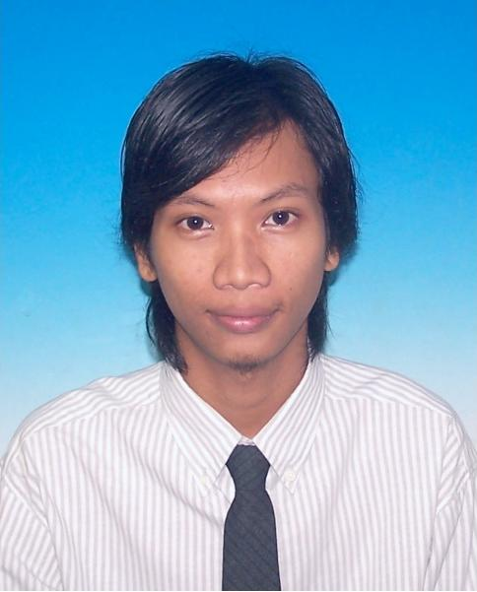**ZARIN IZWAN BIN DOLAH JUDIN**

840608-14-5737

37-07-12 SRI PERAK

BANDAR BARU SENTUL

51000 KUALA LUMPUR

017-6204900

[mr.dreadlockers@gmail.com](mailto:mr.dreadlockers@gmail.com)

**CAREER OBJECTIVE**

To work in a challenging and stimulating environment with opportunity to use my current experience and to enrich my knowledge and enhance my experience. To contribute towards the achievement of organizational objective by applying my professional skills.

**STRENGTHS**



* Ability to adapt various working environment and able to cope with the competitive technology
* Goal oriented
* Able to liaise with other divisions in achieving results and a team player
* Willingness to learn

**EDUCATION BACKGROUND**

|  |  |  |
| --- | --- | --- |
| **YEAR** | **INSTITUTION** | **QUALIFICATION** |
| 2004 - 2002 | Advanced Management and Technology Centre ( PTPL College )  Kuala Lumpur | Certificate in Information System Administrative  Grade : Level 3 |
| 2001 - 1999 | Sekolah Menengah Kebangsaan Pandan Indah,  Ampang, Selangor | Sijil Pelajaran Malaysia (SPM)  Commerce  Grade : 3 |
| 1999 – 1997 | Sekolah Menengah Kebangsaan  Pandan Indah,  Ampang, Selangor | Penilaian Menengah Rendah (PMR)  Grade : 1A, 1B, 3C, 2D & 1E |

**CO-CURRICULAR ACTIVITIES**

|  |  |  |
| --- | --- | --- |
| **YEAR** | **INSTITUTION** | **ACTIVITIES** |
| 2004 - 2002 | PTPL College, Kuala Lumpur | * Committee of Kelab Kembara * Involved in hiking expedition to Gunung Tahan, Pahang * Involved in hiking expedition to Gunung Ledang, Johor |
| 2001 - 1997 | Sekolah Menengah Kebangsaan Pandan Indah  Ampang, Selangor | * Committee of Kadet Pertahanan Awam * Committee of Geografi Club * Committee of Pembimbing Rakan Sebaya Club * Committee of Hockey Club |

**LANGUAGES**

|  |  |  |
| --- | --- | --- |
| **LANGUAGE** | **SPOKEN** | **WRITTEN** |
| Bahasa Malaysia | Excellent | Excellent |
| English | Good | Good |

**SKILLS**

Proficient with Microsoft Office (Word, Excel and Power Point)

**EMPLOYMENT EXPERIENCE**

**2015 – Present**

**A&A Telecommunication Sdn Bhd**

**Site Engineer - Coordinator**

* Responsible for coordinating and supervising all projects.
* Handle site survey involve in taking picture, measurement, site access and make reports.
* Responsible new equipment installations and modifications in the telecommunication systems.
* Responsible for carrying out commissioning and integration, installation, modifications maintenance, repair, troubleshooting related to telecommunications.
* Coordinating the work activities of subcontractors.
* Carrying out technical acceptance testing of new telecommunication equipment.

**2011– 2015**

**Triple Task Industries Sdn Bhd**

**Supervisor – Installation**

* Responsible in installing new TM @ Telekom Malaysia telephone line, streamyx internet line and ISDN data line.
* Advised cable design aspects of field installed products to the customer.
* Maintaining the telephone line.

**2009 – 2011**

**NKS Systems Sdn Bhd**

**Technician - Maintenance**

* Responsible in maintenance and repair TM @ Telekom Malaysia service line.
* Involved in maintaining telephone line, streamyx internet line and ISDN data line.
* Troubleshoot the problem & repair line for customers.

**2007 – 2009**

**Astro Measat Broadcast Network System Sdn Bhd**

**Activation Officer – Activation Department**

* Responsible in processing customer astro account.
* Contact customers, make a confirmation about their details and answered customers queries.
* Troubleshoot customers problem and find a solutions.
* Key in and updating customers details into company database system.
* Answered calls from installers and activated customers account.

**2006 – 2007**

**Tokio Marine Insurance (M) Berhad – *General Insurance***

**Senior Clerk Claims – Claim Department**

* Responsible in accident, windscreen, theft and own damaged claims.
* Assist walk in customer, answered about their queries and troubleshoot the problems.
* Register new cases, appointed insurance adjuster and do the adjustment.
* Make a record and stored the data in the company database system.

**2005 – 2006**

**ING Insurance (M) Berhad – *Life Insurance***

**Clerk Customer Service – Data Cleansing Department**

* Responsible in updating customer latest information.
* Contact customers, collect and updating their latest details.
* Pulled out the old details from the company database and merged with the new latest updated customers information.
* Contact customers, informed about their new details and answered customers queries.

**2004 – 2005**

**ExxonMobil (M) Berhad**

**Clerk Scanning – Card & Document Preparation Department**

* Responsible in upgrading filing systems.
* Scanned document from the hardcopy data then converted to softcopy data.
* Key in and verifying data then stored to the company database.
* Adding bonus point for the Esso X-Change card holder.
* Checking and updating customer information.

**REFERENCES**

1. Mohammad Irman

Executive

Astro Measat Broadcast Network System Sdn Bhd

Tel : 019 – 2732376